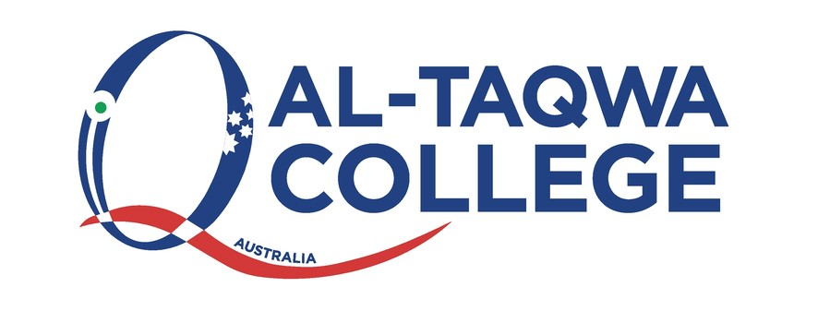

**Occupational Health and Safety Policy**

1. **Statement of Context & Purpose**

**Our focus and commitment:**

Al-Taqwa College is committed to the aim of providing a sustained College environment that is without risks to health and safety for all employees, students, visitors, contractors and the wider Islamic/Australian community connected to our College. We recognise that maintaining the highest possible standards of health and safety is a key responsibility for our Leaders and for all persons across all areas of the College including the Principal, Board, Management, Supervisors, Employees, Contractors and the wider Islamic/Australian community connected to the College.

Through a systematic approach to health & safety we are committed and focused on an open, engaged consultative framework to all of our health and safety matters. We highly value all of our people, the community and environment. We are focused on the promotion of caring for each other’s health, safety and wellbeing as well as one’s own.

Hazard, risk identification, solution, monitoring and review are integral to our College’s health and safety system.

We strive to meet and exceed our legislative responsibilities and requirements:

- Through the provision and maintenance of safe plant and systems of work

- The monitoring and maintaining of systems for the safe use, handling, storage and transportation of plant and substances

- The provision of adequate staff welfare facilities

- The provision of appropriate information, training and supervision for all employees, students, parents and stakeholders.

- Through participation, collaboration and co-operation by all at the College in order to achieve safety goals and excellence.

- Through safety policy and procedure revision to ensure compliance and update.

- To celebrate together our achievements and success in the accomplishment of outstanding safety advances at the College.

**2.0 Help for Non-English Speakers**

If you require assistance in understanding this policy, please contact Al-Taqwa College (03) 9269 5000.