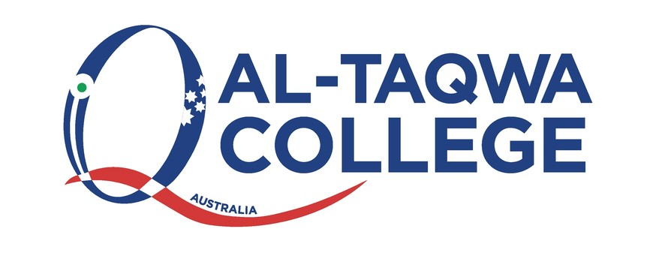

**Diversity and Inclusion Policy**

All children have a right to be treated fairly. This right was referred to by the Prophet (s.a.w) in

the saheeh hadeeth:

“Fear Allah and treat your children fairly”

(Narrated by Al-Bukhari, 2447; Muslim, 1623).

**1.0 Statement of Context & Purpose (Why is this process was created)**

At Al-Taqwa College we have a strong commitment to child safety and are committed to fulfilling

our duty to all students in accordance with Ministerial Order 1359. At Al-Taqwa College we are

committed to creating and maintaining a child safe and child friendly school, where children and

young people are safe and feel safe. Our aim is to ensure all students feel safe, happy and are

empowered as we support and respect all members of the College community. This includes the

safety and wellbeing of our students from culturally and linguistically diverse backgrounds,

students with a disability, Aboriginal and Torres Strat children and vulnerable children. All

members of our College Community have a responsibility to care for children and young people

to positively promote their wellbeing and protect them from any kind of harm or abuse.

Al-Taqwa College is enriched by and celebrates the diversity of our whole College community, for

these reasons discrimination, harassment, vilification, bullying and victimisation will not be

tolerated.

We are committed to ensuring that the working environment is free from discrimination,

harassment, bullying, vilification and victimisation.

At Al-Taqwa College we are committed to making sure every member of our College community

regardless of their background or personal attributes, is treated with respect and dignity. AlTaqwa College strives to provide a safe, inclusive and supportive environment for all students and

members of our College community.

We acknowledge that in society some people are treated unfairly or unfavourably because of

characteristics such as sex or race. We also acknowledge and celebrate the diversity of

backgrounds and experiences in our College community and will not tolerate behaviours,

language or practices that label, stereotype or demean others.

**2.0 Target Audience**

All staff

- All students

- College Community

- Volunteers

- Placement Teacher

**3.0 Implementation**

At Al-Taqwa College we will:

- Ensure that all students and members of our college community are treated with respect

and dignity

- Ensure that all students are not discriminated against and where necessary are

accommodated to participate in education and all school activities (e.g. sports, concerts,

excursions etc.) on the same basis as their peers.

- Acknowledge and respond to the diverse needs and strengths of all students

- Encourage empathy and fairness towards others

- Contribute to the positive learning, engagement and wellbeing outcomes for students

- Take action to prevent discrimination, harassment and bullying and to promote a safe and

inclusive school

- Take appropriate action to address and resolve any issues and complaints

Al-Taqwa College is a multicultural community with a broad range of cultural backgrounds. We

aim to celebrate this diversity through various cultural celebration throughout the year such as

Harmony Day, Cultural Dress Day Al-Aqsa Week etc.

Every member of the Al-Tawa College has the right to learn and work in a safe and inclusive

environment free of discrimination, harassment and bullying. Along with this right comes the

responsibility to respect and promote the behaviours consistent with this policy. We understand

that we have a special obligation to make reasonable adjustments to accommodate students with

disabilities. A reasonable adjustment is a measure or action taken to assist al students to

participate in their education on the same basis as their peers. Reasonable adjustments will be

made for students with disabilities through our Additional Needs Department in consultation with

their parents / carers, their teachers and if appropriate their treating practitioners. For further

information please refer to our Additional Needs Policy.

***Complaints***

We encourage all members of the College community to to attempt to resolve complaints and

concerns through the school. All complaints will be treated confidentially, fairly and consistently

and resolved as promptly as possible. For further information please refer to our Complaints policy.

***Definitions***

Personal attribute: a feature of a person’s background or personal characteristics that is protected

by State or Commonwealth anti-discrimination legislation.

**Related policies and procedures**

• Child Safety Code of Conduct

• Child Safety

• Child Safety Responding and Reporting Obligations Policy and Procedures

• Mandatory Reporting Policy

• Discrimination, Harassment and Bullying Policy

• Complaints Policy

• Additional Needs

• Behaviour Management Guidelines

**4.0 Help for Non-English Speakers**

If you require assistance in understanding this policy, please contact Al-Taqwa College (03) 9269 5000.