All children have a right to be treated fairly. This right was referred to by the Prophet (s.a.w) in

the saheeh hadeeth:

“Fear Allah and treat your children fairly”

(Narrated by Al-Bukhari, 2447; Muslim, 1623).

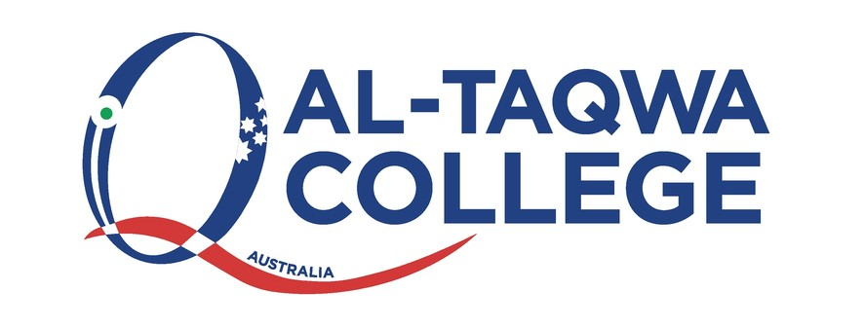

**Child Safety Responding and Reporting Obligations Policy**

**Statement of Context & Purpose (Why is this process was created)**

Al-Taqwa College child safety statement:

This statement demonstrates Al-Taqwa College's strong commitment to child safety and is

committed to fulfilling its duty to all students in accordance with Ministerial Order 1359.

At Al-Taqwa College we are committed to creating and maintaining a child safe and childfriendly school, where children and young people are safe and feel safe. Our aim is to ensure all

students feel safe, happy and are empowered as we support and respect all members of the

College community. This includes the safety and wellbeing of our students from culturally and

linguistically diverse backgrounds, students with a disability, Aboriginal and Torres Strait

children and vulnerable children. All members of our College Community have a responsibility to

care for children and young people, to positively promote their wellbeing and protect them

from any kind of harm or abuse.

***The purpose of this policy is to:***

• Ensure school staff are aware of and comply with their reporting and legal obligations, including mandatory reporting and reportable conduct obligations, to protect the safety and wellbeing of children and young people

• Explain the process following a report to Department of Families, Fairness and Housing

Child Protection service (Child Protection)

• Explain training requirements for school staff.

***SUMMARY:***

School staff have a range of reporting and legal obligations to protect children and young people

from abuse.

• School staff must be aware of and comply with their legal obligations to report

suspected child abuse and provide ongoing appropriate support.

• School staff must follow the [Four Critical Actions](https://www.schools.vic.gov.au/report-child-abuse-schools?Redirect=1) where there is an incident, disclosure

or suspicion of child abuse. The Four Critical Actions outline who an incident, disclosure

or suspicion should be reported to.

• When dealing with an incident, disclosure or suspicion of child abuse, staff should ensure

that the principal and school leadership team is made aware of the concern and are

involved in providing ongoing appropriate support.

• If an incident or allegation involves an employee, volunteer or contractor at the school,

staff must also follow the College’s policy on Reportable Conduct and report the incident

to the College Principal/or delegate through the child safety email **childsafety@wicv.net**

The Principal/or delegate will assess the allegations and report them to the Commission

for Children and Young People, if appropriate.

• Where a school staff member has reported a concern to [Child Protection](https://providers.dffh.vic.gov.au/making-report-child-protection) but they

continue to have concerns for the child after Child Protection has closed the case, they

may escalate the matter through Child Protection complaints management processes or

reporting concerns from the principal to their regional area executive director.

***DETAILS:***

School staff have a vital role in protecting children from harm and are well placed to observe signs

or behaviours that may indicate risks of child abuse.

School staff must follow the [Four Critical Actions](https://altaqwacollege-my.sharepoint.com/personal/nomar_wicv_net/Documents/Updated%20Policies%202024/Four%20Critical%20Actions) as soon as they witness an incident, receive a

disclosure, or form a reasonable belief that a child has been abused or is at risk of being abused.

**Reporting and Legal Obligations Relating to Suspicions, Disclosures or Incidents Of Child Abuse**

School staff have a range of reporting and legal obligations to report suspected child abuse and

provide ongoing appropriate support. These are described below.

Child Safe Standards

All schools are required to comply with the Child Safe Standards and Ministerial Order 1359 to

create and maintain a child safe organisation where children and young people are protected

from abuse.

For information on the Child Safe Standards, refer to [Child Safe Standards](https://ccyp.vic.gov.au/child-safe-standards/the-11-child-safe-standards/).

**Reportable Conduct Scheme**

Principals must notify the Commission for Children and Young People as soon as possible after

becoming aware of an allegation of reportable conduct against a current or former staff

member, contractor or volunteer. This applies regardless of whether the alleged victim is or was

a student at the school.

There is an allegation of reportable conduct where a person has a reasonable belief that there has been:

• A sexual offence committed against, with, or in the presence of a child, whether or not a

criminal proceeding in relation to the offence has been commenced or concluded

• Sexual misconduct committed against, with, or in the presence of a child

• Physical violence committed against, with, or in the presence of a child

• Any behaviour that causes significant emotional or psychological harm to a child

• Significant neglect of a child.

All allegations of reportable conduct must be reported to the College Principal. An allegation

does not need to be substantiated to be reported.

The College Principal/or delegate will report allegations of reportable conduct raised against

department staff (including contractors, volunteers, allied health workers and other office

holders) who are 18 years or over to the Commission for Children and Young People (CCYP).

For more information, refer to: [Reportable Conduct Scheme](https://ccyp.vic.gov.au/resources/reportable-conduct-scheme/reportable-conduct-scheme-information-sheets/#TOC-1).

**Reportable Conduct Scheme**

Principals must notify the Commission for Children and Young People as soon as possible after

becoming aware of an allegation of reportable conduct against a current or former staff

member, contractor or volunteer. This applies regardless of whether the alleged victim is or was

a student at the school.

There is an allegation of reportable conduct where a person has a reasonable belief that there

has been:

• A sexual offence committed against, with, or in the presence of a child, whether or not a criminal proceeding in relation to the offence has been commenced or concluded.

• Sexual misconduct committed against, with, or in the presence of a child

• Physical violence committed against, with, or in the presence of a child

• Any behaviour that causes significant emotional or psychological harm to a child

• Significant neglect of a child.

All allegations of reportable conduct must be reported to the College Principal. An allegation

does not need to be substantiated to be reported.

The College Principal/or delegate will report allegations of reportable conduct raised against

department staff (including contractors, volunteers, allied health workers and other office

holders) who are 18 years or over to the Commission for Children and Young People (CCYP).

For more information, refer to: [Reportable Conduct Scheme](https://altaqwacollege-my.sharepoint.com/personal/nomar_wicv_net/Documents/Updated%20Policies%202024/Reportable%20Conduct%20Scheme)

**Mandatory reporting**

A mandatory reporter must report to Child Protection as soon as practicable if in the course of

practising their profession or carrying out their duties, they form a belief on reasonable grounds

that:

• A child has suffered, or is likely to suffer, significant harm as a result of physical and/or

sexual abuse and

• the child’s parents have not protected or are unlikely to protect the child from harm of

that type.

It may be a criminal offence not to report in these circumstances.

Individuals who are required to report:

• Victorian Institute of Teaching (VIT) registered teachers, including principals, and early

childhood teachers

• School staff who have been granted permission to teach by the VIT

• Registered medical practitioners, nurses and midwives

• Police officers

• Registered psychologists

• People in religious ministry

• Early childhood workers

• Youth justice workers

• Out-of-home care workers (excluding voluntary foster and kinship carers).

• School counsellors including staff who provide direct support to students for mental,

emotional, or psychological wellbeing, including (but not limited to) school health and

wellbeing staff, primary welfare officers, student wellbeing coordinators, mental health

practitioners, chaplains, and Student Support Services staff.

**Criminal offences**

*Failure to disclose*

All adults must report to Victoria Police when they form a reasonable belief that a sexual

offence has been committed by an adult against a child under the age of 16.

Failure to disclose the information may be a criminal offence unless there is a ‘reasonable

excuse’ or an individual has an 'exemption' from doing so.

If an adult that reasonably believes that a sexual offence has been committed against a child

under the age of 16 by another adult, then they must call Victoria Police on 000 or the local

police station.

For more information, refer to the Department of Justice and Community Safety

website: [Failure to disclose offence](https://www.justice.vic.gov.au/node/1813/failure-to-disclose-offence).

**Failure to protect**

Principals or school leadership staff who become aware that an adult associated with the school

(such as an employee, contractor, volunteer or visitor) poses a risk of sexual abuse to a child

under the care of the school (including grooming) must take all reasonable steps to remove or

reduce that risk.

This may include removing the adult from child-connected and child-related work pending

investigation. Failure to do so may be a criminal offence.

The obligation to protect a child applies to any staff member in a position of authority (for

example principals, assistant principals and campus principals).

For more information, refer to the Department of Justice and Community Safety

website: [Failure to Protect Offence](https://www.justice.vic.gov.au/node/1813/failure-to-disclose-offence).

**Duty of care**

All school staff have a duty of care to take reasonable steps to protect children in their care from

harm that is reasonably foreseeable. In relation to suspected child abuse, reasonable steps may

include (but are not limited to):

• Acting on concerns and suspicions of abuse as soon as practicable

• Seeking appropriate advice or consulting with other professionals or agencies

• Reporting the suspected child abuse to appropriate authorities such as Victoria Police

and Child Protection (refer to Four Critical Actions)

• Arranging counselling and/or other appropriate welfare support for the child

• Providing ongoing support to the child and young person

• Sharing information with other school staff who will also be responsible for providing

ongoing support to the child.

For more information, refer to:

• [Duty of Care](https://www2.education.vic.gov.au/pal/duty-of-care/policy)

• [Your reporting and legal obligations](https://www.schools.vic.gov.au/your-reporting-and-legal-obligations?Redirect=1) (PROTECT)

• [Identifying and responding to all forms of abuse in Victorian schools (PDF)](https://www.education.vic.gov.au/Documents/about/programs/health/protect/ChildSafeStandard5_SchoolsGuide.pdf)

• Child Safe Standard 7: Ensure that processes for complaints and concerns are child

focused, refer to:

o [Child Safety Standard 7: Regulations for schools](https://www.vic.gov.au/child-safe-standards-schools-complaints-processes-regulations)

o [Child Safety Standard 7: Guidance for schools](https://www.vic.gov.au/schools-complaints-process-guidance)

**Responding to student sexual offending**

Guidance for staff on what action to take if you suspect, or are witness to student sexual

offending is available at [Identify and respond to student sexual offending](https://www.education.vic.gov.au/school/teachers/health/childprotection/Pages/stusexual.aspx)

Significant concerns for the wellbeing of a child

All concerns about the wellbeing of a child (or unborn child) should be taken seriously and acted

upon.

Any adult can make a referral to [Child FIRST](https://altaqwacollege-my.sharepoint.com/personal/nomar_wicv_net/Documents/Updated%20Policies%202024/Child%20FIRST) and/or The [Orange Door](https://orangedoor.vic.gov.au/) if they:

• Have a significant concern for a child’s wellbeing

• The issue of concern has a low-to-moderate impact on the child

• The child’s immediate safety is not compromised

• Believe that the child and/or family will act on the referral and be supportive of it.

School staff must contact Victoria Police if:

• There is any concern for a child’s immediate safety

• A child is partaking in any risk-taking activity that is illegal and extreme in nature or poses a high risk to the child or any other person.

School staff can contact Child Protection if:

• After consideration of all available information the staff member forms a view that the

child needs protection and:

• The staff member believes that the child’s parents/carers will not be open to support

from family services to address their child’s wellbeing.

For further information, refer to: [Responding to other concerns about the wellbeing of a child](https://www.education.vic.gov.au/school/teachers/health/childprotection/Pages/responding.aspx).

For contact details visit:

• [Child FIRST and family services](https://services.dhhs.vic.gov.au/referral-and-support-teams)

• The Orange Door [The Orange Door](https://www.vic.gov.au/familyviolence/the-orange-door.html)

• [Safe and Equal](https://safeandequal.org.au/) – for information and guidance to help respond to family violence

• 1800 RESPECT (Tel: 1800737732) – for family violence victims/survivors to be referred to counselling and information

• Child Protection – visit [Making a report to child protection](https://providers.dhhs.vic.gov.au/making-report-child-protection)

• Victoria Police – call 000 or the local police station.

**Related policies and procedures**

This Child Safety Policy is to be read in conjunction with other related school policies,

procedures, and codes. These include our:

• Child Safety Policy

• Child Safety Code of Conduct

• Child Safety Responding and Reporting Obligations Policy

• Mandatory Reporting Policy

• Discrimination, Harassment and Bullying Policy

• Grievances Policy

• Visitors and Volunteers Policy

**Resources**

• [Child Safe Standards](https://ccyp.vic.gov.au/child-safe-standards/the-11-child-safe-standards/)

• [Reportable Conduct Scheme](https://ccyp.vic.gov.au/child-safe-standards/the-11-child-safe-standards/)

• [Child Information Sharing](https://www.vic.gov.au/child-information-sharing-scheme)

**Relevant legislation**

• [Children, Youth and Families Act 2005 (Vic)](https://www.legislation.vic.gov.au/in-force/acts/children-youth-and-families-act-2005)

• [Child Wellbeing and Safety Act 2005 (Vic)](https://www.legislation.vic.gov.au/in-force/acts/child-wellbeing-and-safety-act-2005)

• [Crimes Act 1958 (Vic)](https://www.legislation.vic.gov.au/in-force/acts/crimes-act-1958)

• [Education and Training Reform Act 2006 (Vic)](https://www.legislation.vic.gov.au/in-force/acts/education-and-training-reform-act-2006)

• [Education and Training Reform Regulations 2017 (Act)](https://www.legislation.vic.gov.au/in-force/statutory-rules/education-and-training-reform-regulations-2017)

• [Ministerial Order 1359 - Implementing the Child Safe Standards (PDF)](https://www.education.vic.gov.au/Documents/about/programs/health/protect/Ministerial_Order.pdf)

**Appendices**

Appendix 1: Four critical actions

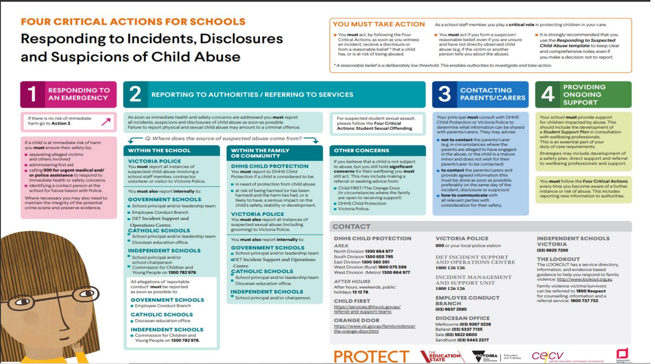

Appendix 2: Four critical actions for sexual offending

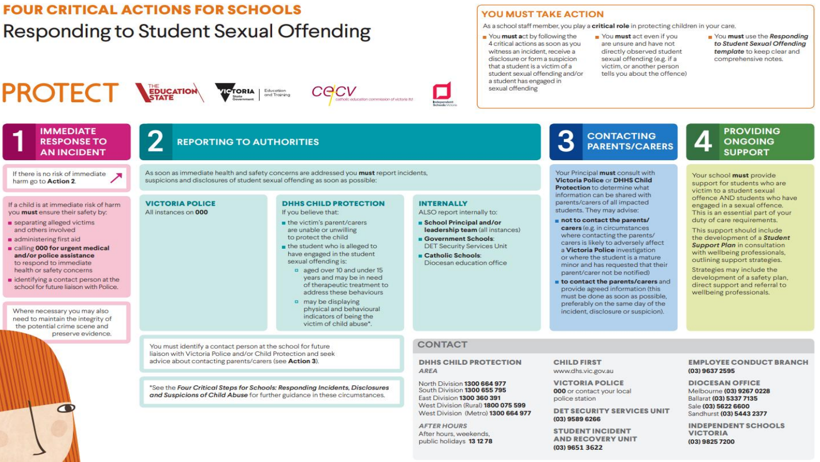

**Help for Non-English Speakers**

If you require assistance in understanding this policy, please contact Al-Taqwa College (03) 9269 5000.