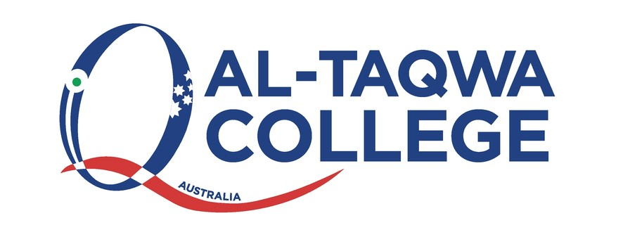

**AL-Taqwa College Child Safety Code of Conduct**

1. **Statement of Context & Purpose**

This statement demonstrates Al-Taqwa College's strong commitment to child safety and is

committed to fulfilling its duty to all students in accordance with Ministerial Order 1359. At Al-

Taqwa College we are committed to creating and maintaining a child safe and child-friendly school,

where children and young people are safe and feel safe. Our aim is to ensure all

students feel safe, happy and are empowered as we support and respect all members of the

College community. This includes the safety and wellbeing of our students from culturally and

linguistically diverse backgrounds, students with a disability, Aboriginal and Torres Strait

children and vulnerable children. All members of our College Community have a responsibility to

care for children and young people, to positively promote their wellbeing and protect them

from any kind of harm or abuse.

This policy demonstrates Al-Taqwa College’s strong commitment to child safety and is committed

to fulfilling its duty to all students in relation to Ministerial order No. 1359.

This policy applies to all staff who work or volunteers at this college. This includes all teaching

and non-teaching professions, volunteers and contractors. This code of conduct works in line with

the Child Safety policy, College Code of Conduct, Mandatory Reporting Policy and other relevant

college policies and procedures.

This policy aims to promote a child safe environment for all students to ensure they feel safe from

any harm including abuse. Our goal is to create a child safe and friendly environment where our

students feel safe, have fun and reach their potential.

This policy is in accordance with the Ministerial order 1359 and the Education Training and Reform

Act.

**This policy aims to:**

• Commit to child safety standards

• Clarify the expectations of all staff when dealing with students

* Outline how breaches of this code of conduct will be handled

**2.0 Target Audience**

All staff, volunteers, contractors and school board members.

**3.0 Implementation**

Al-Taqwa College aims to embed child safety as a priority in our organizational culture through

our leadership, commitment and expectations of appropriate behaviour. The College will screen

and train our staff and establish a response and reporting system to identify and reduce or remove

risks of child abuse. Staff will also be trained to ensure students feel empowered through

information and programs.

Al-Taqwa College places a high expectation of professionalism and requires staff to conduct

themselves appropriately at all times. This includes within school times, excursions, camps and

other school related activities. This also includes after hours.

All staff, volunteers and contractors are required to abide to the below behaviours and conduct at

all times

**Acceptable behaviours**

***All staff, volunteers and board/school council members are responsible for supporting the safety***

***of children by:***

• Adhering to the school’s child safe policy and upholding the College’s statement of

commitment to child safety at all times

• Taking all reasonable steps to protect children from abuse

• Treating everyone in the College community with respect

• Listening and responding to the views and concerns of children, particularly if they are telling

you that they or another child has been abused or that they are worried about their

safety/the safety of another child

• Promoting the cultural safety, participation and empowerment of Aboriginal and Torres

Strait Islander children (for example, by never questioning an Aboriginal and Torres Strait

Islander child’s self-identification)

* Promoting the cultural safety, participation and empowerment of children with culturally

and/or linguistically diverse backgrounds (for example, by having a zero tolerance towards

discrimination)

• Promoting the safety, participation and empowerment of children with a disability (for

example, during personal care activities)

• Ensuring as far as practicable that adults are not alone with a child

• Reporting any allegations of child abuse or child safety concerns to the child safety

committee at childsafety@wicv.net

• Understanding and complying with all reporting obligations as they relate to mandatory

reporting and reporting under the Crimes Act 1958

• If an allegation of child abuse is made, ensuring as quickly as possible that the child(ren) are

safe

• Reporting to the Victorian Institute of Teaching any charges, committals for trial or

convictions in relation to a sexual offence by a registered teacher, or certain allegations or

concerns about a registered teacher.

**Unacceptable behaviours**

Staff and volunteers must not:

• Ignore or disregard any suspected or disclosed child abuse

• Develop any ‘special’ relationships with children that could be seen as favouritism (for

example, the offering of gifts or special treatment for specific children)

• Exhibit behaviours with children which may be construed as unnecessarily physical (for

example inappropriate sitting on laps)

• Put children at risk of abuse (for example, by locking doors)

• Initiate unnecessary physical contact which children or do things of a personal nature that

a child can do for themselves, such as toileting or changing clothes

• Engage in open discussions of a mature or adult nature in the presence of children (for

example, personal social activities)

• Be alone with a student of the opposite gender that is not in a public area as far as

practicable

• Use inappropriate language in the presence of children (swearing, derogatory language or

offensive labels)

• Express personal views on cultures, religion, race or sexuality in the presence of children

• Discriminate against any child (because of age, gender, race, religion, culture, vulnerability,

sexuality, ethnicity or disability

• Have unwarranted contact with a child or their family outside of school without the

school’s leadership knowledge and/or consent or the school governing authority’s

approval (for example, unauthorised after hours tutoring, private instrumental/other

lessons or sport coaching). Accidental contact, such as seeing people in the street, is

appropriate.

• Communicate directly with a student through personal or private contact channels

(including by social media, email, instant messaging, texting etc) except where that

communication is reasonable in all the circumstances, related to schoolwork or extracurricular activities or where there is a safety concern or other urgent matter

• Unwarranted exchange of personal contact details such as phone number, social

networking sites or email addresses

• Photograph or video a child without the consent of the parent, guardians or child

• Photograph or video a child using personal device

• Work with children whilst under the influence of alcohol or illegal drugs

• Consume alcohol, drugs or smoke at school or at school events in the presence of children.

**This list is subject to review and may not be an exhaustive list.

**Breaches of the Policy**

***Reporting breaches of unacceptable behaviour***

1.All Al-Taqwa staff, volunteers, contractors and any other member of the school

community involved in child-connected work who breach this Child Safety Code of

Conduct may be subject to disciplinary procedures in accordance with their employment

agreement or relevant industrial instrument, professional code or terms of engagement.

2. In instances where a reportable allegation has been made, the matter will be managed in

accordance with the Reportable Conduct Scheme and may be subject to referral to

Victoria Police.

3. All breaches and suspected breaches of the Al-Taqwa Child Safety Code of Conduct must

be reported to childsafety@wicv.net

4. If the breach or suspected breach relates to the principal, contact the treasurer of the

school board Mr Mohamed Muyeen on foamart@gmail.com

5.All incident reports will be kept strictly confidential; however, the college reserves the

right to discuss with key child safety committee members

6.The college will keep record of the suspected incident.

**Investigation of breaches of unacceptable behaviour**

If a staff, volunteer or contractors has been reported in breach of an unacceptable behaviour then

the following process will take place:

Identified staff will be investigated by the child safety committee, head of primary or

junior/senior head of secondary to determine if claims are substantiated or

unsubstantiated, which may include:

a. Speaking to witness, students and/or parents and/or the alleged staff, volunteer

or contractors

b. will compile a thorough written report of the incident with findings and

recommendations

c. This will be reported to the members of the child safety committee and the

Principal (or his authorised delegate)

d. If the allegation is found to be substantiated then the performance and conduct

process will be applied which may include formal warnings, termination of

employment and/or being reported to authorities. This may further result in staff

members losing their VIT Registration or Working with Children Check.

e. Students and parents will be offered and encouraged to attend counselling

Related policies and procedures

This Child Safety Policy is to be read in conjunction with other related school policies,

procedures, and codes. These include our:

• Child Safety Code of Conduct

• Child Safety Responding and Reporting Obligations Policy and Procedures

• Mandatory Reporting Policy

• Discrimination, Harassment and Bullying Policy

• Grievances Policy

• Visitors and Volunteers Policy

• Behaviour Management Guidelines

• Privacy Policy

**4.0 Resources**

[**Child Safe Standards**](https://ccyp.vic.gov.au/child-safe-standards/the-11-child-safe-standards/)

[**Reportable Conduct Scheme**](https://ccyp.vic.gov.au/resources/reportable-conduct-scheme/reportable-conduct-scheme-information-sheets/#TOC-1)

[**Child Information Sharing**](https://www.vic.gov.au/child-information-sharing-scheme)

**5.0 Appendices**

**1. Child Safety Reporting Flowchart**

**Appendix 1:**

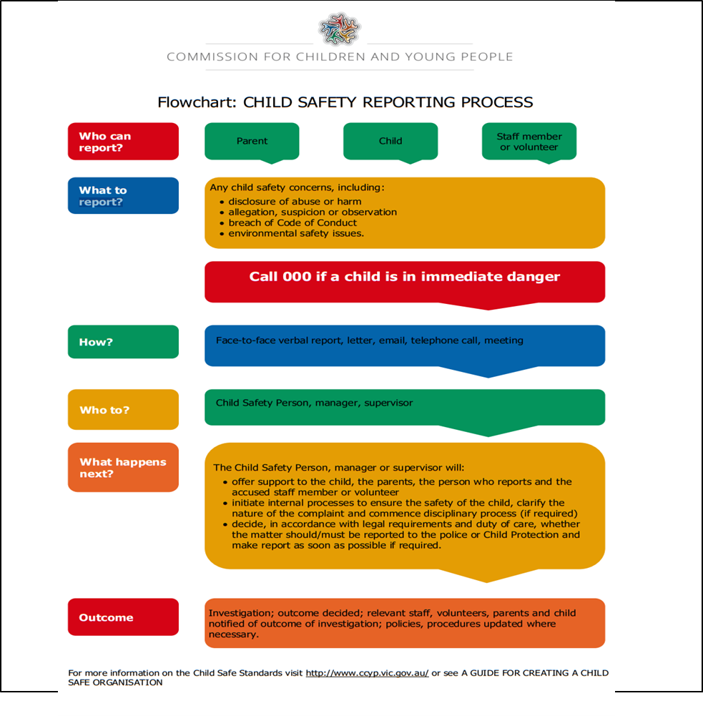

**5.1 Help for Non-English Speakers**

If you require assistance in understanding this policy, please contact Al-Taqwa College (03) 9269 5000.