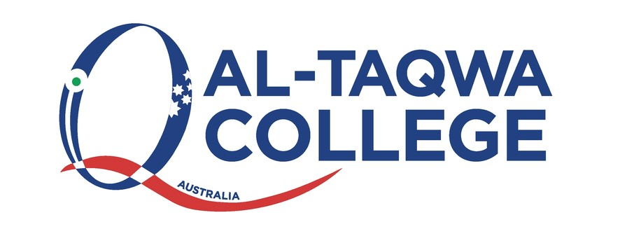

**Al-Taqwa College Child Safety Statement and Commitment**

**Al-Taqwa College Child Safety Statement and Commitment**

At Al-Taqwa College we have a strong commitment to Child Safety and are committed to fulfilling our duty to all students in accordance with Ministerial Order 1359. At Al-Taqwa College we are committed to creating and maintaining a child safe and a child friendly school, where children and young people are safe and feel safe. Our aim is to ensure all students feel safe, happy and are empowered as we support and respect all members of the College community. This includes the safety and wellbeing of our students from culturally and linguistically diverse backgrounds, students with a disability, Aboriginal and Torres Strait children and vulnerable children. All members of our College Community have a responsibility to care for children and young people, to positively promote their wellbeing and protect them from any kind of harm or abuse.

The leadership Team at Al-Taqwa College is committed to Child Safety:

✓ We want children to be safe, happy and empowered.

✓ We support and respect all children, as well as our staff and volunteers.

✓ We are committed to the safety, participation and empowerment of children.

✓ We have zero tolerance of child abuse, and all allegations and safety concerns will be treated very

seriously and consistently with our robust policies and procedures.

✓ We have legal and moral obligations to contact authorities when we are worried about a child’s safety,

which we follow rigorously.

✓ We are committed to the cultural safety of Aboriginal children, the cultural safety of children from

culturally and / or linguistically diverse backgrounds and to providing a safe environment for children with disabilities and other vulnerable children.

✓ We have zero tolerance for racism of any sort and in any form.

**Help for Non-English Speakers**

If you require assistance in understanding this policy, please contact Al-Taqwa College (03) 9269 5000.